Kubernetes 03

- Create a ClusterIP service for an Apache web server pod.
Step 1: Create Apache Pod
vi apache-pod.yaml
apiVersion: v1
kind: Pod
metadata:
name: apache-pod
labels:
app: apache
spec:
containers:
- name: apache
image: httpd
ports:
- containerPort: 80
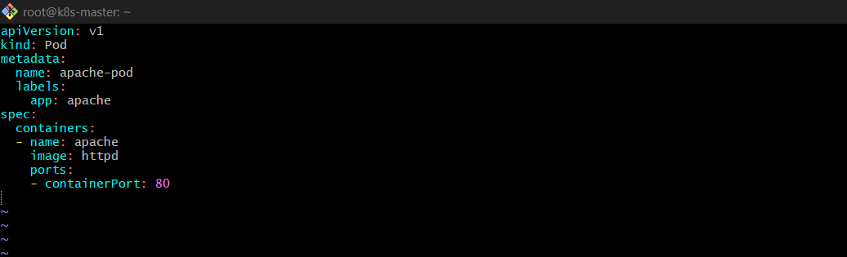
kubectl apply -f apache-pod.yaml
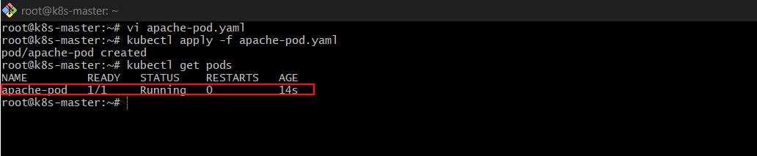

Step 2: Create ClusterIP Service
vi apache-service.yaml
apiVersion: v1
kind: Service
metadata:
name: apache-clusterip
spec:
type: ClusterIP
selector:
app: apache
ports:
- port: 80
targetPort: 80
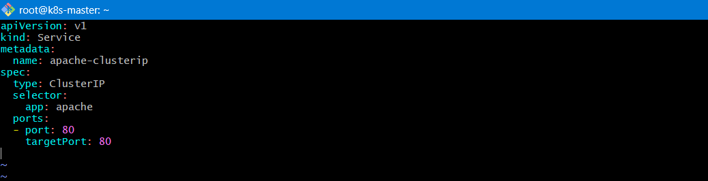
kubectl apply -f apache-service.yaml
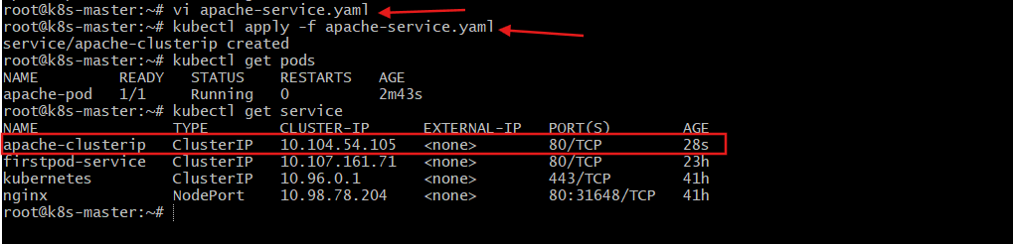
Validation
kubectl get pods
kubectl get svc
kubectl describe svc apache-clusterip
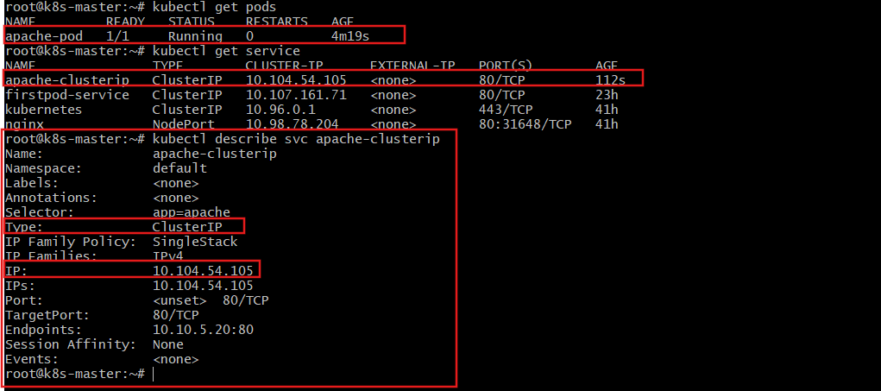
Explanation
- ClusterIP exposes service only inside the cluster
- Service routes traffic to pods using label selector
- Default service type is ClusterIP

- Expose a Nginx pod externally using a NodePort service.
Step 1: Create Nginx Pod
vi nginx-pod.yaml
apiVersion: v1
kind: Pod
metadata:
name: nginx-pod
labels:
app: nginx
spec:
containers:
- name: nginx
image: nginx
ports:
- containerPort: 80
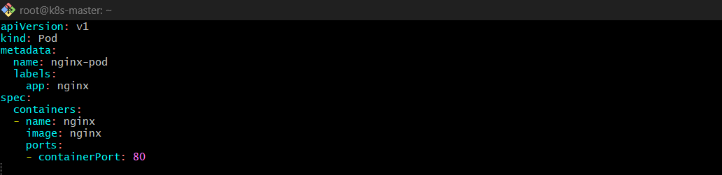
kubectl apply -f nginx-pod.yaml
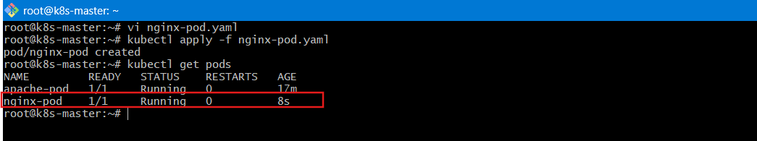
Step 2: Create NodePort Service
vi nginx-nodeport.yaml
apiVersion: v1
kind: Service
metadata:
name: nginx-nodeport
spec:
type: NodePort
selector:
app: nginx
ports:
- port: 80
targetPort: 80
nodePort: 30007
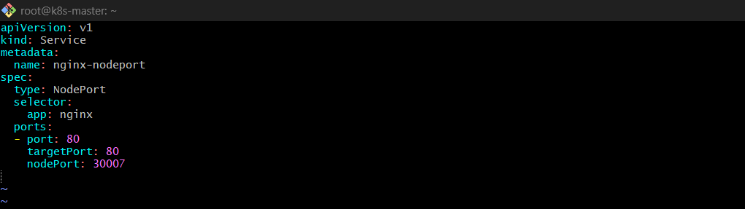
kubectl apply -f nginx-nodeport.yaml
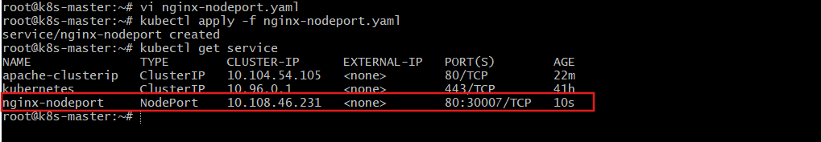
Validation
kubectl get service
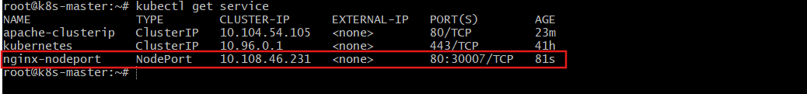
Access in browser:
http://<NodeIP-public-ip>:30007
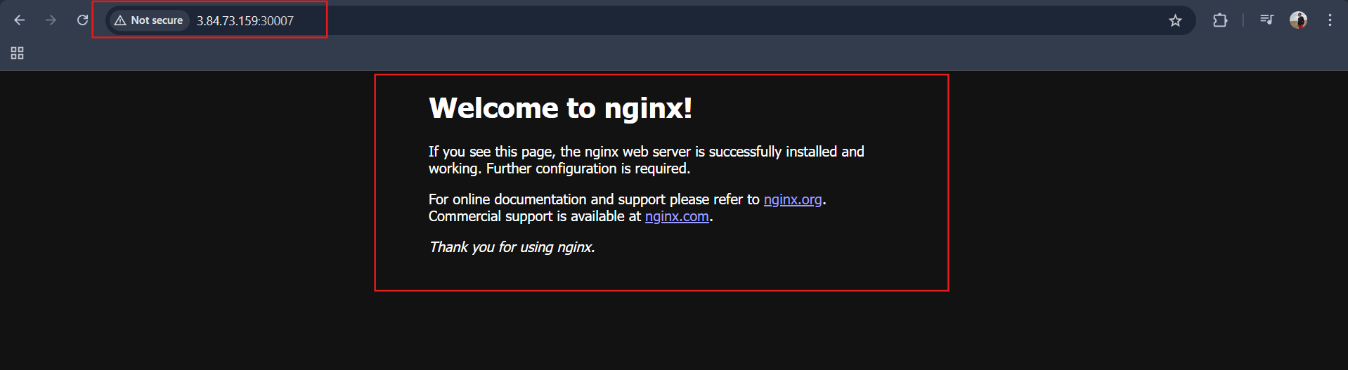
Get node IP:
kubectl get nodes -o wide
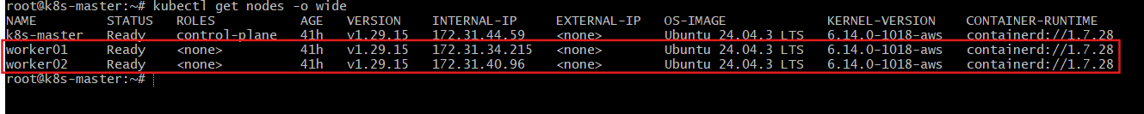
Explanation
- NodePort exposes service externally
- Opens port (30000–32767) on all nodes
- Traffic → NodeIP:NodePort → Service → Pod

- Deploy a ReplicationController to maintain 3 replicas of a Nginx pod.
Deploy a ReplicationController (3 Nginx Pods)
vi nginx-rc.yaml
YAML
apiVersion: v1
kind: ReplicationController
metadata:
name: nginx-rc
spec:
replicas: 3
selector:
app: nginx-rc
template:
metadata:
labels:
app: nginx-rc
spec:
containers:
- name: nginx
image: nginx
ports:
- containerPort: 80
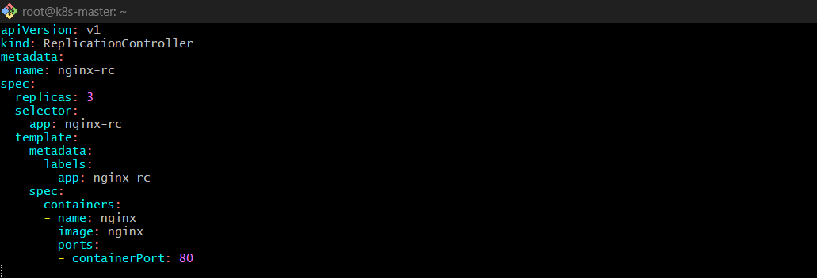
kubectl apply -f nginx-rc.yaml
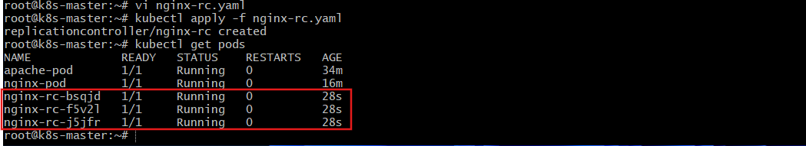

Validation
kubectl get rc
kubectl get pods
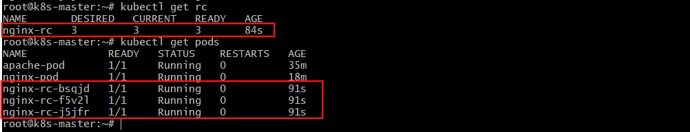
Delete one pod:
kubectl delete pod <pod-name>
You’ll see a new one created automatically.
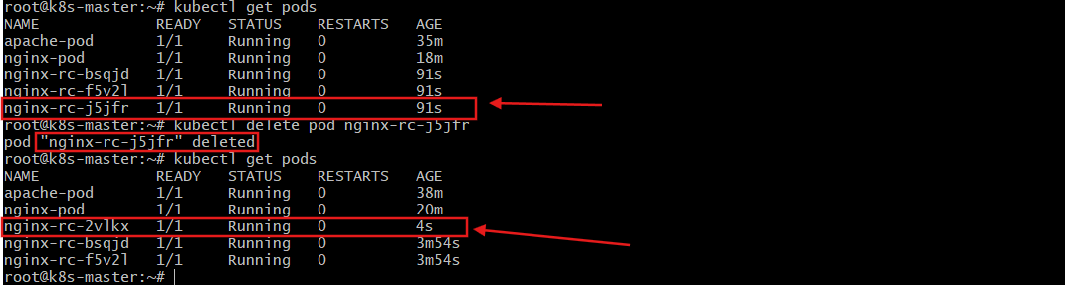
Explanation
- Ensures desired replicas always running
- If pod dies → new pod created
- Older controller (before ReplicaSet)

- Scale the ReplicationController from 3 replicas to 5 replicas.
Scale ReplicationController (3 → 5)
Method 1: Command
kubectl scale rc nginx-rc --replicas=5
Method 2: Edit
kubectl edit rc nginx-rc
Change:
replicas: 5
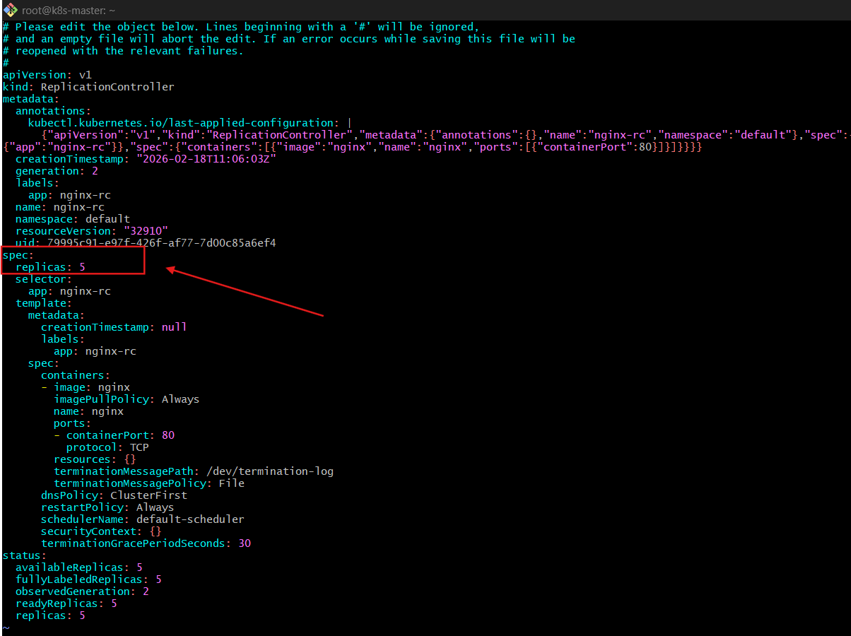
Validation
kubectl get rc
kubectl get pods
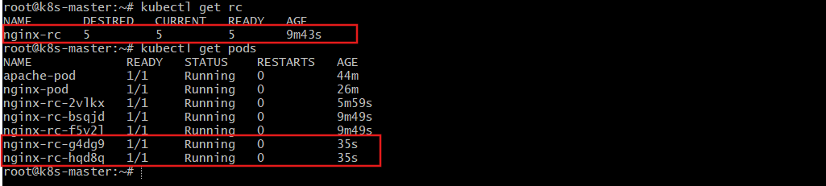
Explanation
Controller compares:
- Desired replicas = 5
- Current replicas = 3
- Creates 2 more pods.

- Create a ReplicaSet to manage pods based on multiple labels (prod and test).
Create a ReplicaSet with Multiple Labels (prod + test)
vi multi-label-rs.yaml
YAML
apiVersion: apps/v1
kind: ReplicaSet
metadata:
name: multi-label-rs
spec:
replicas: 2
selector:
matchLabels:
env: prod
tier: test
template:
metadata:
labels:
env: prod
tier: test
spec:
containers:
- name: nginx
image: nginx
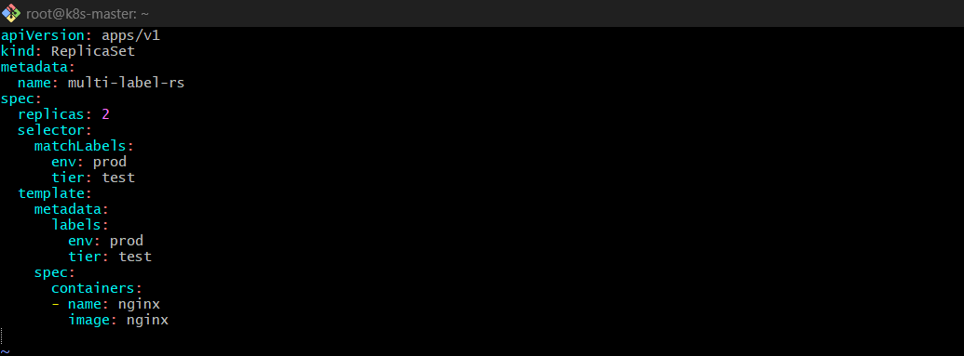
kubectl apply -f multi-label-rs.yaml
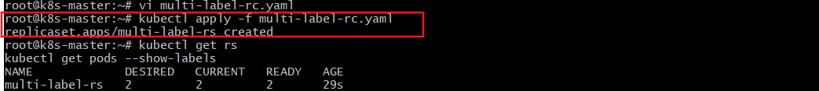
Validation
kubectl get rs
kubectl get pods --show-labels
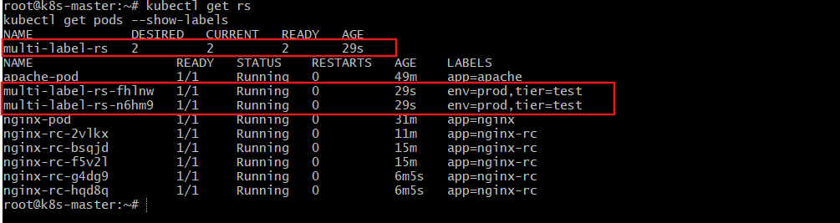
Explanation
- matchLabels requires:
- env=prod AND tier=test
- Both labels must match.

- Deploy a ReplicaSet that excludes pods with the label backend.
ReplicaSet Excluding Pods with Label backend
Use matchExpressions
vi exclude-rs.yaml
YAML
apiVersion: apps/v1
kind: ReplicaSet
metadata:
name: exclude-backend-rs
spec:
replicas: 2
selector:
matchExpressions:
- key: tier
operator: Exists
- key: tier
operator: NotIn
values:
- backend
template:
metadata:
labels:
tier: frontend
spec:
containers:
- name: nginx
image: nginx
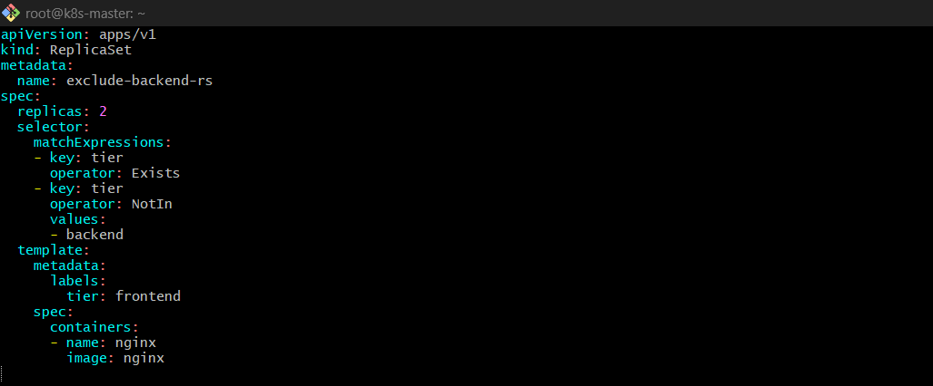
kubectl apply -f exclude-rs.yaml
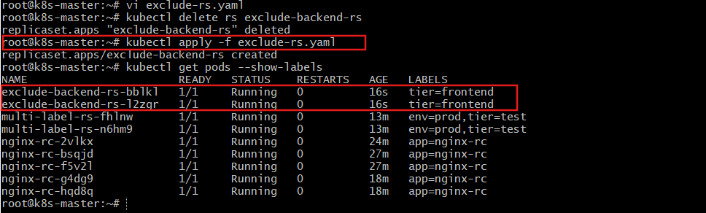
Validation
kubectl get rs
kubectl get pods --show-labels
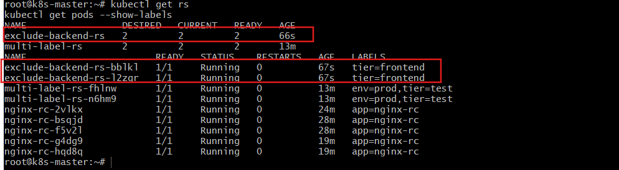
Explanation
- NotIn means:
- Select pods where:
- Advanced label selector logic.

- Test load balancing across multiple pods using a NodePort service.
Test Load Balancing via NodePort
Step 1: Create ReplicaSet (3 pods)
kubectl scale rs multi-label-rs --replicas=3
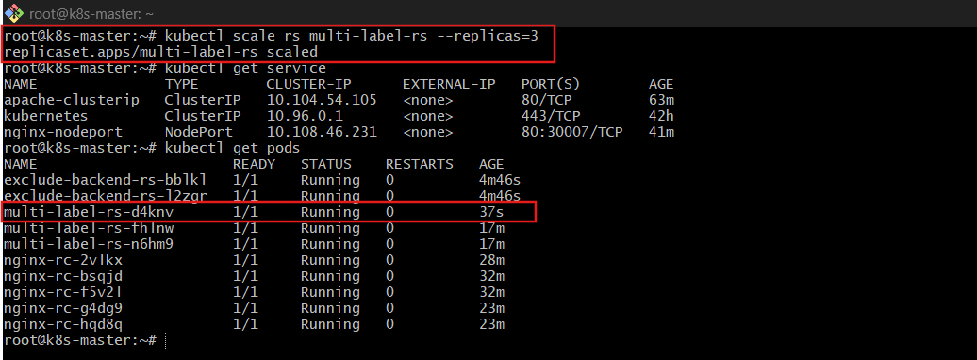
Step 2: Create NodePort Service
vi nginx-lb.yaml
apiVersion: v1
kind: Service
metadata:
name: nginx-lb
spec:
type: NodePort
selector:
env: prod
tier: test
ports:
- port: 80
targetPort: 80
nodePort: 30008
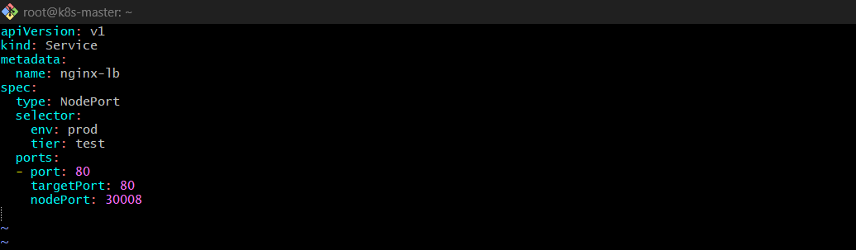
kubectl apply -f nginx-lb.yaml
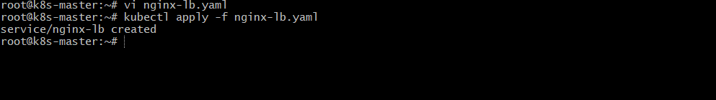
Validation
Confirm 3-pods are running
kubectl get pods -l env=prod,tier=test -o wide
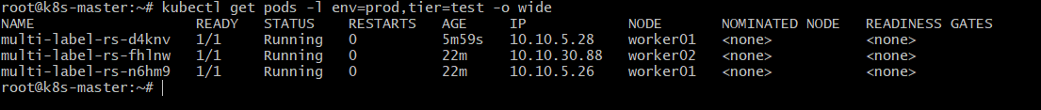
Confirm service is available and running
kubectl get svc nginx-lb
Access multiple times:
http://<NodeIP-public-ip>:30008
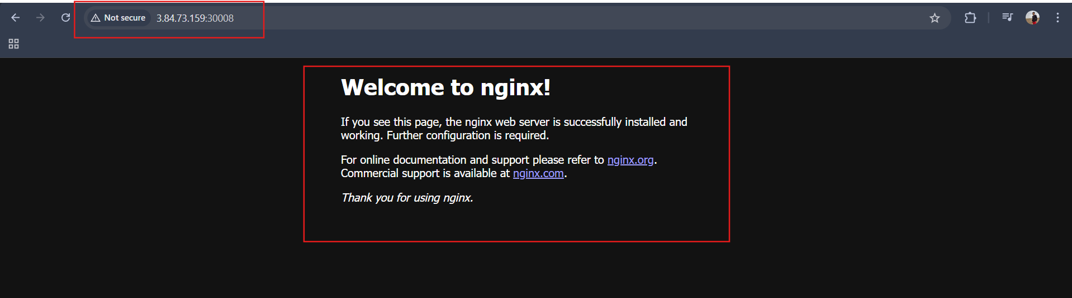
To clearly see load balancing, modify pods:
kubectl exec -it <pod> -- hostname
Refresh multiple times → traffic distributed.
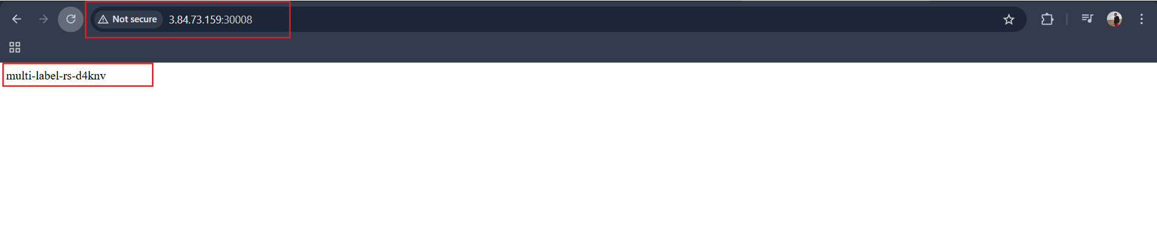
Explanation
Service uses:
- kube-proxy
- iptables/ipvs
- Round-robin load balancing
Traffic distributed across all matching pods.

- Delete a ReplicationController without affecting the running pods.
Delete ReplicationController Without Deleting Pods
By default:
Deleting RC deletes pods
To keep pods:
kubectl delete rc nginx-rc --cascade=orphan

Validation
kubectl get rc
kubectl get pods
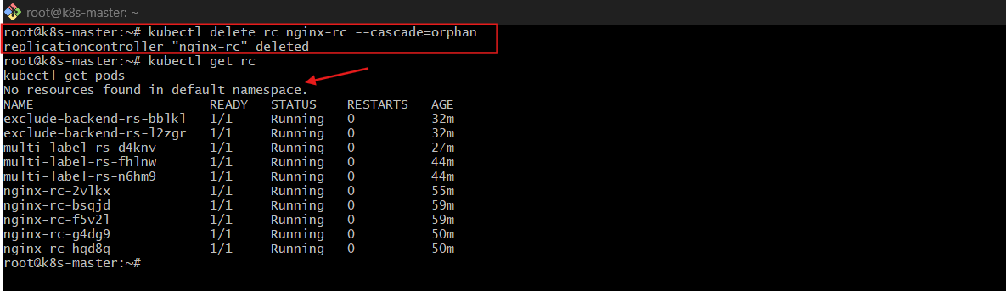
Pods remain running.
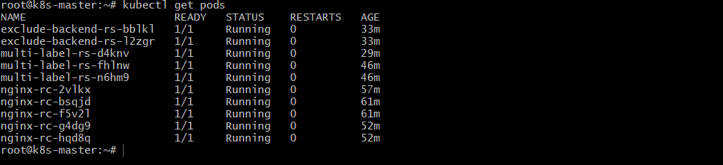
Explanation
--cascade=orphan: Deletes controller
- Removes owner reference
- Pods become independent

